System Functional Architecture

for the

Unmanned
Control & Tracking System
(UCATS)

DJ³K Team

Kurt Chewning
Jennifer Greene
Dave Manley
Jeanette Smith
John Smith

Sponsors: Dr. Kuo-Chu Chang
&
Ashwin Samant

Department of Systems Engineering & Operations Research
SYST 798 Applied Project Course
Fall 2009

TABLE OF CONTENTS

1 Introduction 4
2 Level 1 Functional and Physical Architecture 4
2.1 Level 1 Functional Architecture 4
2.2 Level 1 Generic Physical Architecture 6
2.3 Functional-to-Physical Architecture Mapping 6
3 Level 2 Functional and Generic Architecture 7
3.1 UAV Communications 7
3.1.1 Communicate With UAV 7
3.1.2 Communication Module Physical Architecture 8
3.2 Operator Interface with UCATS 8
3.2.1 Accept Operator Requests and Provide Feedback 8
3.3 Interface Module 10
3.4 UCATS Computations 11
3.4.1 Compute UAV Presets 11
3.4.2 Presetting Algorithm Module Architecture 12
3.5 Providing Surveillance Video to the Operator 12
3.5.1 Accept Video and Display 12
3.5.2 UCATS Video Architecture 13
4 Instantiated Physical Architecture 13
4.1 UCATS Generic Physical Architecture 13
4.2 Instantiated Physical Architecture Description 14
4.2.1 Instantiated Communications Module Architecture 14
4.3 Instantiated Interface Module 15
4.3.1 Presetting Algorithm Module 16
4.3.2 Video Module 16
4.4 UCATS SW Architecture 16
4.5 Integrated Instantiated Design 18
5 Conclusions 19
5.1 Mission Level Requirements Functional Allocations 20
5.2 Operational Requirements Functional Allocations 20
APPENDICES 1
APPENDIX A: Acronyms 2
APPENDIX B: Functional Architecture AoA 3

List of Figures
Figure 1: UCATS Level One Functional Architecture 5
Figure 2: UCATS Level One IDEF0 5
Figure 3: UCATS Physical Architecture 6
Figure 4: Communicate With UAV IDEF0 8
Figure 5: Comms Module Physical Architecture 8
Figure 6: Accept Operator Request and Provide Feedback IDEF0 10
Figure 7: Figure Interface Module Architecture 11
Figure 8: Communicate UAV Presets IDEF0 12
Figure 9: Presetting Algorithm Module Architecture 12
Figure 10: Accept Video and Display IDEF0 13
Figure 11: Video Module Architecture 13
Figure 12: UCATS Complete Physical Architecture 14
Figure 13: UAV Communication Relay Concept 15
Figure 14: UCATS SW Architecture 18
Figure 15: Integrated UCATS Instantiated Architecture 19

Introduction
This document summarizes the system level functional and physical architecture for the Unmanned Control & Tracking System (UCATS). The process used to determine the top level functional and physical architecture involved a top down decomposition of the functional and physical architecture. This process also involved decomposing the functional architecture and developing the generic physical architecture in a parallel process. The process used to develop the functional and physical architecture of the UCATS includes:
- Define the required UCATS functions based on the external systems diagram, UCATS operational concept, and UCATS Use Cases.
- Develop the Level One Functionality; develop the Generic Physical Architecture; define inputs, outputs, and constraints for all functions; and verify that all functionalities map to the generic physical architecture.
- Decompose Level One functionality into Level Two functionality; decompose the Level One Generic Physical Architecture into a Level Two architecture; define inputs, outputs, and constraints for all Level Two functions; and verify that all Level Two functionalities map to the generic physical architecture.
- Map functions to SRS requirements and verify that all UCATS requirements map to a UCTAS function and component.
- Develop the instantiated physical architecture based on the functional and generic physical architecture.

Level 1 Functional and Physical Architecture

Level 1 Functional Architecture
The top level function for UCATS is Provide Command and Control Functions. This function satisfies all of the mission level requirements of the UCATS as defined in the UCATS System Requirements Specification, SRS. Provide Command and Control Functions is decomposed by four level one functions. These functions are: Communicate with UAV, Accept Operator Requests and Provide Feedback, Compute UAV Presets, and Accept Video and Display. Figure 1 below shows the functional hierarchy for Provide Command and Control Functions. For each level one function inputs, outputs, and constraints were defined for each function. The complete level one architecture is shown using IDEF0 modeling in Figure 2 below.

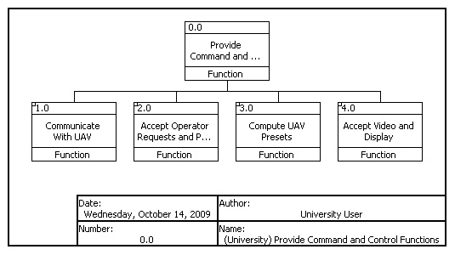
Figure 1: UCATS Level One Functional Architecture

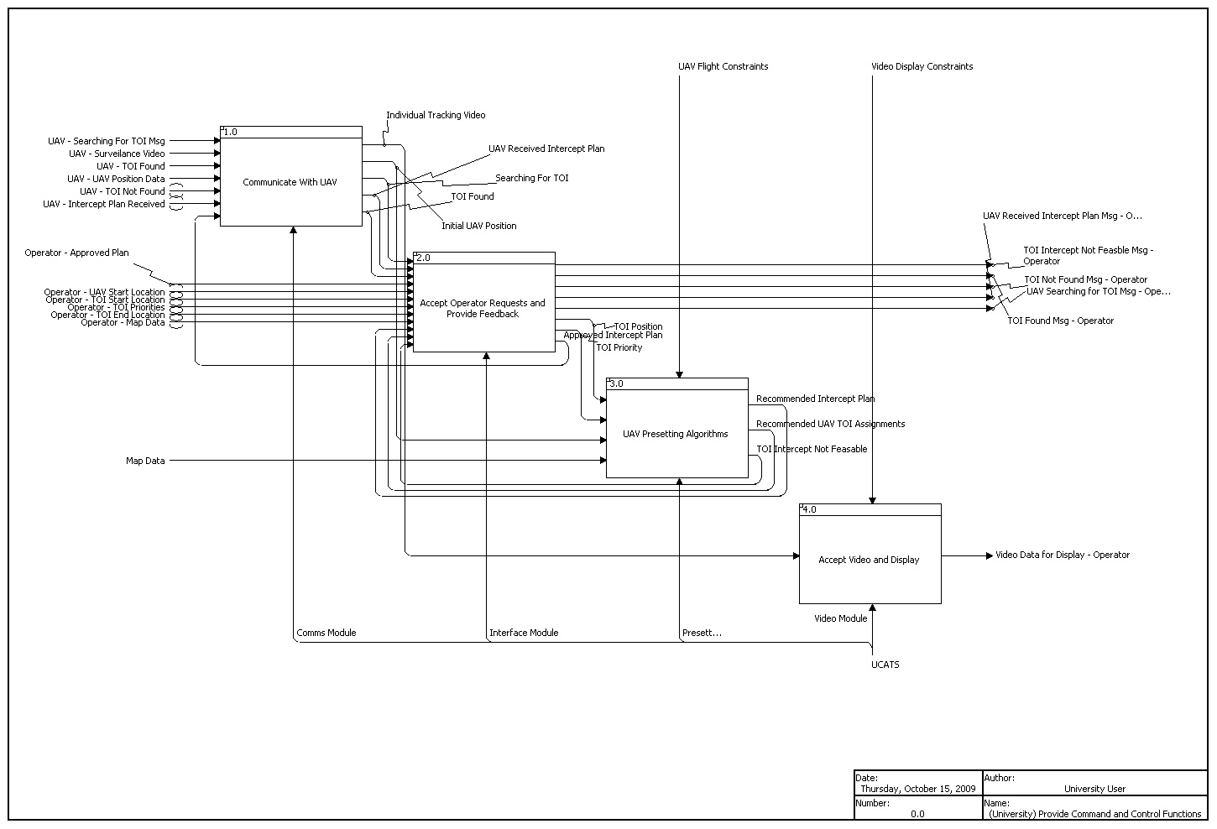
Figure 2: UCATS Level One IDEF0

Level 1 Generic Physical Architecture
Figure 3 summarizes the generic physical architecture for the UCATS. The UCATS is composed of:
- Communications Module: The Communications Module sends data and messages to and receives messages from the Unmanned Arial Vehicle, UAV. This component comprises the interface between the UCATS and the UAV.
- Interface Module: The Interface Module comprises of the Human Computer Interface of the UCATS. The Interface Modules accepts data from the user and displays UCATS data to the user. The Interface Module contains the windows and displays necessary for the user to interact with the UCATS.
- UCATS Presetting Algorithm Module: The Algorithm Module executes the calculations which make recommendation to the user. The Algorithm Module calculates estimated Target of Interest, TOI route, estimated UAV intercept routes, and UAV to TOI assignments.
- Video Module: The Video Module receives single video feeds from each UAV. The Video Module consolidates the video feeds and displays the videos to the user.
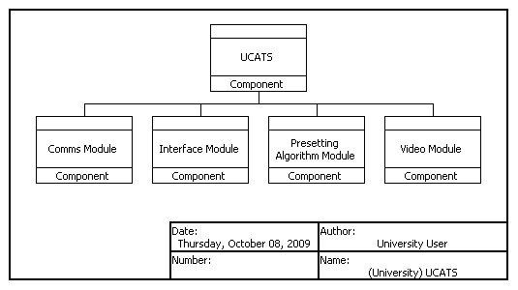
Figure 3: UCATS Physical Architecture

Functional-to-Physical Architecture Mapping
Table 1 summarizes the UCATS Generic Physical Architecture to level 1 functionality mapping. As shown in Table 1, all UCATS level one functions are mapped into the UCATS generic physical architecture.

Component | Function
UCATS | Provide Command and Control Functions
Comms Module | Communicate with UAV
Interface Module | Accept Operator Requests and Provide Feedback
Presetting Algorithm Module | Compute UAV Presets
Video Module | Accept Video and Display
Table 1: UCATS Physical Architecture Mapping into UCATS Functions

Level 2 Functional and Generic Architecture

UAV Communications

Communicate With UAV
The Communicate with UAV functions receives all messages from the UAV to the UCATS. This function also sends messages from UCATS to the UAV. The Communicate with UAV function is decomposed into three sub functions: Receive and Transmit UAV Comms, Encrypt and Decrypt Comms, and Manage Comms. These sub functions are defined in Table 2 below.

Function Name | Brief Description
Received and Transmit UAV Comms | Receives encrypted messages from the UAV and sends encrypted messages from UCATS to the UAV
Encrypt and Decrypt UAV Comms | Manages the Encryption and Decryption of UAV messages.
Manage Comms | Sends decrypted data to the other components of UCATS
Table 2: Communicate with UAV Functional Decomposition

The functional architecture for Communicate With UAV is shown graphically using IDEF0 in Figure 4 below.
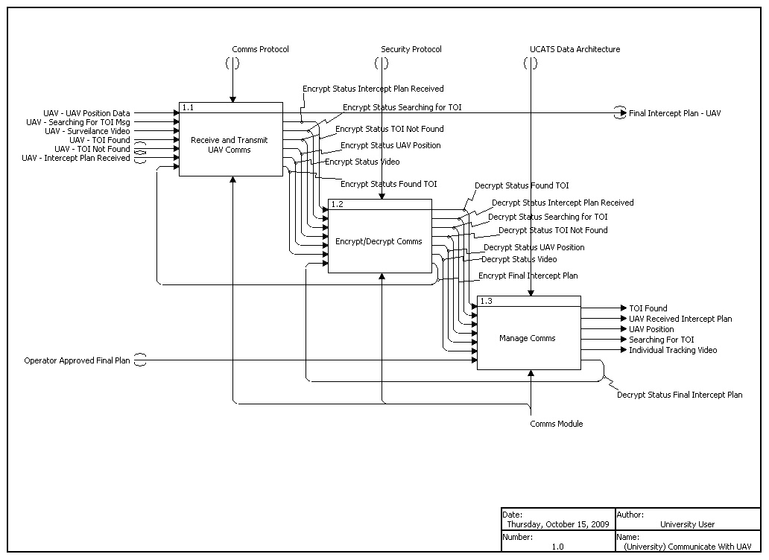
Figure 4: Communicate With UAV IDEF0

Communication Module Physical Architecture
Figure 5 shows the comms module physical architecture. The comms module has three components: Receiver/Transmitter, Encrypt/Decrypt Module, and the Comms Processor.
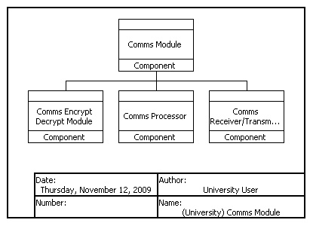
Figure 5: Comms Module Physical Architecture

Operator Interface with UCATS

Accept Operator Requests and Provide Feedback
The Accept Operator Requests and Provide Feedback function is the top level function for user interaction with UCATS. This function accepts data from operator and provides and operator notifications. For the purposes of this functional description data displayed to the operator or any operator notifications are defined as outputs even though in reality the UCATS is not actually sending data to the operator. Accept Operator Requests and Provide Feedback is decomposed into nine sub functions. These sub functions are defined with a brief description for each function in Table 3 below.

Function Name | Brief Description
Accept User Input | Accepts user input data. This data includes TOI Start and Stop location, TOI Priority, Map Data, and UAV start location
Accept User Plan Approval | Allows the operator to Approve a recommended UAV intercept route
Display UAV Intercept Route | Displays the expected UAV route to the operator
Display UAV Position | Displays the current UAV position to the operator based on data from the UAV
Display UAV to TOI Assignments | Displays the recommended UAV to TOI assignments to the operator
Notify Operator TOI Found | Alerts the operator that the UAV has located the TOI
Notify Operator TOI Intercept Not Feasible | Alerts the operator that a UAV is unable to intercept a TOI
Notify Operator UAV Received Intercept Plan | Alerts the operator that the UAV has received the flight plan to intercept the TOI
Notify Operator UAV Searching | Alerts the operator that the UAV has reached the expected intercept location and is searching for the UAV
Table 3: Accept Operator Requests and Provide Feedback Functional Decomposition

The functional architecture for Accept Operator Requests and Provide Feedback is shown graphically using IDEF0 in Figure 6 below.
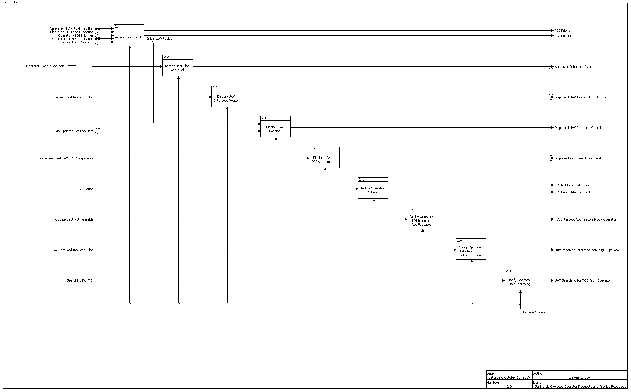
Figure 6: Accept Operator Request and Provide Feedback IDEF0

Interface Module
Figure 7 shows the interface module physical architecture. The interface module has two components: Display and UCATS Interface CPU.
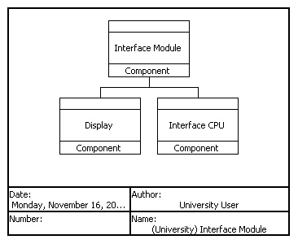
Figure 7: Figure Interface Module Architecture

UCATS Computations

Compute UAV Presets
This is the top level function for computing UAV command and control recommendations for the operator. This function computes the UAV preset information. UAV preset information is defined as the estimated TOI Route based on the TOI start and end location, the UAV Intercept Plan to intercept the TOI, and the UAV to TOI assignments. The Compute UAV Presets function executes the UAV Presetting Algorithm. This algorithm is composed of three main functions Calculate Planned TOI Route, Calculate UAV to TOI Assignments, and Calculate UAV Intercept Route. The function Calculate UAV to TOI Assignments also determines if the UAV can intercept the TOI. This is defined as a sub function Determine TOI Intercept Feasibility. These sub functions are defined with a brief description for each function in Table 4 below.

Function Name | Brief Description
Calculate Planned TOI Route | Calculates the expected TOI route
Calculate UAV to TOI Assignments | Computes the UAV to TOI assignments also computes whether or not a UAV can feasibly intercept a TOI
Calculate UAV Intercept Route | Calculates an estimated UAV route including routing around any no fly zones
Table 4: Compute UAV Presets

The functional architecture for Compute UAV Presets is shown graphically using IDEF0 in Figure 8 below.
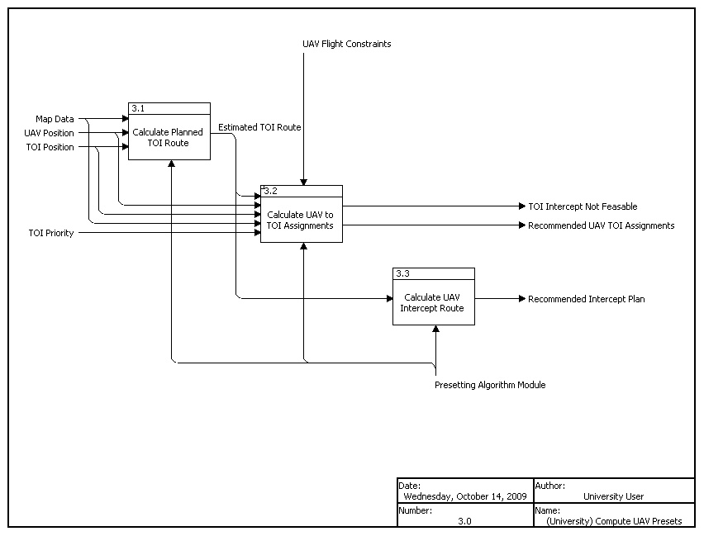
Figure 8: Communicate UAV Presets IDEF0

Presetting Algorithm Module Architecture
Figure 9 shows the presetting module physical architecture. The presetting module has two components: Algorithm and UCATS CPU.

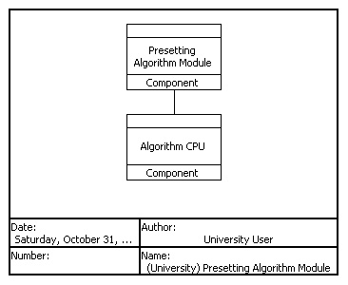
Figure 9: Presetting Algorithm Module Architecture

Providing Surveillance Video to the Operator

Accept Video and Display
This function receives individual video from the UAVs and displays consolidated video to the operator. This function is decomposed into two sub functions Consolidate Feeds and Display Video. These sub functions are defined with a brief description for each function in Table 5 below.

Function Name | Brief Description
Consolidate Feeds | Consolidates all the separate video feeds into a single display for the operator to view each TOI
Display Video | Displays the consolidated video to the operator
Table 5: Accept Video and Display

The functional architecture for Accept Video and Display is shown graphically using IDEF0 in Figure 10 below.
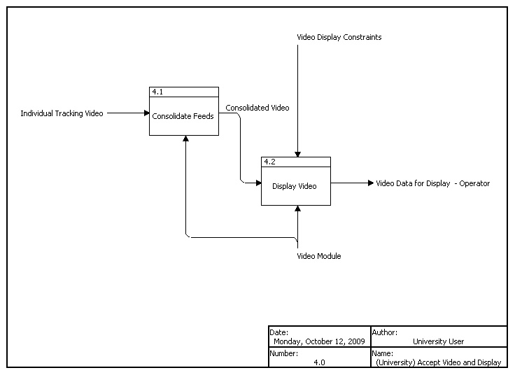
Figure 10: Accept Video and Display IDEF0

UCATS Video Architecture
Figure 11 shows the UCATS Video Architecture. The UCATS Video Module has two components: the television display and the switch.
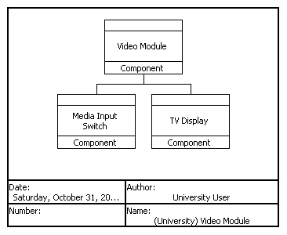
Figure 11: Video Module Architecture

Instantiated Physical Architecture

UCATS Generic Physical Architecture
Figure 12 summarizes the total physical architecture of the UCATS System.
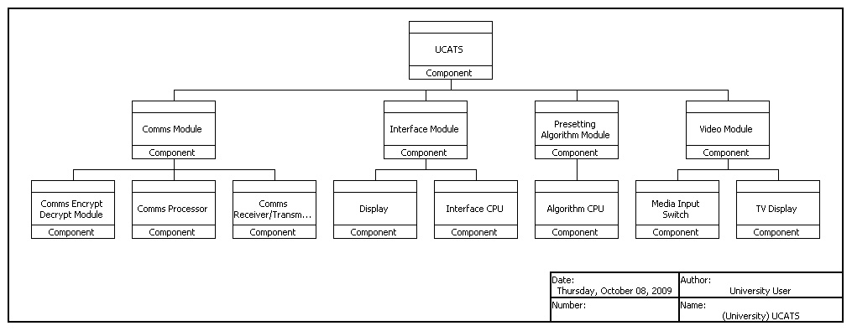
Figure 12: UCATS Complete Physical Architecture

Instantiated Physical Architecture Description
Obviously, all the options considered for the instantiated physical architecture needed to satisfy the generic physical architecture functionality requirements and the SRS. Down-selecting to one instantiation option versus another was based on the applicable Stakeholder Value Mapping preferences for that module. One of the key Stakeholder preferences used in evaluating the available options was extensibility. There are several key technologies being developed that could radically alter and improve UCATS performance; therefore, the ability to accommodate these technologies was important. Therefore, a key attribute of the selected instantiated architectures was modularity, which would facilitate the integration of new technologies as they became available. Another key criterion used to down select the available options was simplicity. It was important that the instantiated design be as simple as possible. Extra components and complexity would reduce reliability and usability; therefore, in the case of the UCATS CPU, the UCATS instantiated architecture had single CPU performing multiple processing functions that addressed different processing aspects of the generic architecture.

Instantiated Communications Module Architecture
The Communications Module is probably the most affected by potential technology upgrades, especially when considering the growth potential in encryption technology, Satellite Communication (SATCOM) radios, accurately determining position, and bandwidth. Therefore, it is imperative that the communication module instantiated architecture be as modular as possible to accommodate the probable future upgrades in these technologies. The UCATS Communication Module components include combining the communications processor functions with the main UCATS processor, a modular COTS stand-alone encryption module, and a receiver/transmitter that has both SATCOMs and LOS radios. Due to the limitations of LOS communications in an urban environment due to building screening, the LOS antenna uses a UAV as a communication relay platform, as shown in figure 13.

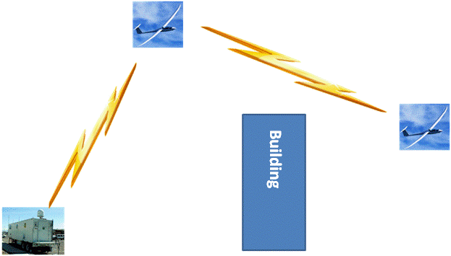
Figure 13: UAV Communication Relay Concept

The primary reason for combine the communications functions with the primary UCATS processor was for reliability. The primary driver for a modular COTS stand-alone Encryption Module was upgradeability. It is anticipated that encryption technology will continue to advance and the upgradeability of a combined radio and encryption function would inhibit the ability to upgrade, and the interfaces modifications needed to upgrade a software-only option would also inhibit upgradeability. Based on current UAV usage, the Receiver/Transmitter would require both SATCOM and LOS communications to communicate with the surveillance UAVs. Ideally, if some of the SATCOM issues can be addressed, the UCATS would switch entirely to SATCOMs; however, until problems such weight, power requirements, bandwidth and packet loss can be corrected, the UCATS Communication Module will require LOS capability. Since the UCATS requires LOS capability, the biggest issue with LOS communications in an urban environment is how to maintain communications when shielded by buildings. A communication relay UAV antenna provided the best solution since it did the best job of maintaining communications, was easily transportable, and easily upgradeable, when compared to the other options.

One benefit of the UAV antenna not addressed in the evaluation is its ability to maintain continuous communications with one of the five available surveillance UAVs, and then maintaining good communications with the other four UAVs. The next step is to conduct the detailed design, which will identify the specific UCATS encryption module, SATCOM and LOS radios, and UAV. However, this is outside the scope of the system level physical instantiation.

Instantiated Interface Module
The Interface Module components include two Liquid Crystal Displays (LCDs), combining the interface processor functions with the main UCATS processor, and developing a HCI design. The LCDs were selected to meet the display function. In order to meet the UCATS availability requirements the UCATS will have two LCDs; however, the second LCD is a passive spares. For the same reliability reasons cited in the communication module discussions, UCATS will combine the interface CPU with the main UCATS CPU. Along with the Interface CPU, the HCI design will provide the user interaction functionality. The HCI design is a software design, which provides the mechanism for the UCATS to interact with the user. The specific HCI design has been notionally designed using preliminary usability assessments, but the final HCI design will require detail design and usability assessments with various operators.

The instantiated HW for the Interface Module is the UCATS Interface CPU and single Liquid Crystal Display (LCD). These units start up in the event of a critical HW or SW failing on the primary nodes. The Presetting Algorithm SW executes on the UCATS CPU.

Presetting Algorithm Module
The Presetting Algorithm Module components include the UCATS main CPU and the Presetting Algorithm. In order to meet the UCATS availability requirements the UCATS will have two CPUs; however, the second CPU is a passive spares. A software based algorithm will provide the logic used to the presetting functions. The Communications Module, Interface Module, and the Presetting Module all share the CPU; however, for the purposes of modeling the system the CPU will be shown as a component of the Presetting Algorithm Module.

Video Module
The Video Module components include a HDMI switch and a single video display. The video module is just used to display video to the operator. The instantiated architecture is a single video display and a switch, which allows the operator to select and change between which UAV video to display.

UCATS SW Architecture
The UCATS functionality cannot be performed without a detailed software design. While the software design will not be finalized until the detail design, the initial software architecture is composed of six components or Common Software Configuration Items (CSCI). The major function of each of the CSCIs and the estimated source lines of code for each CSCI is seen in Table 6 below. For the purposes of this document it is assumed that UCATS is coded in C++. The UCATS prototype is NOT coded in C++. The prototype is coded in JavaScript and Matlab with an interface to Google Earth.

CSCI Name | Function | Estimated SLOC
UCATSMain | The Main UCATS function. This CSCI manages all inerprocess communication of the UCATS Software, SW. This process receives and transmits data to the other processes. This process contains the data for use by the other processes. This process initiates the calculations of the algorithm contained in the UCATSPam process. | 17,000
UCATSHciMain | This process receives data for display from UCATSMain and interfaces with UCATSMap process to ensure data in the UCATS Windows and the Map are identical. The source line of code, SLOC total includes human generated code only. It assumes a GUI builder will be used to build the UCATS windows. | 11,000
UCATSHciMap | This interfaces with the UCATS Map. It is assumed that the actual Map is a Government off the shelf, GOTS or commercial off the shelf, COTS product like Google Earth. | 6,000
UCATSUavInterface | This is the SW interface with the UAV. This process receives the data from the UAV and sends to the Main process. This process also sends the data to the UAV. | 7,000
UCATSPA | This process contains all the algorithms for the UCATS. This process is a single thread which receives requests from the main and responds. | 13,000
UCATSComms | This process manages all incoming and outgoing UCATS communications. This process directs incoming communications to the correct CSCIs and manages outgoing communications within the UCATS communication module. | 12,000
Table 6: UCATS CSCIs

Based on Table 2 it can be seen that the total SLOC estimation for the UCATS SW is 66,000.

For the purposes of modeling the UCATS System the UCATS SW architecture is seen below in Figure 14.
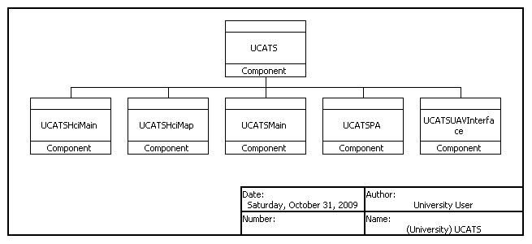
Figure 14: UCATS SW Architecture

Integrated Instantiated Design
Figure 15 summarizes the UCATS instantiated design. This design is contained in a stationary ground control station that is enclosed in a wheeled trailer for high mobility. This ground control station trailer provides high operator safety, distant remote UAVs command and control, simplicity, and environmental protection of the UCATS internal components. The specific components included within the ground control trailer include both SATCOM and LOS radios, an encryption module to encrypt outgoing and decrypt incoming transmissions, and an operator station that contains a PC based computer with two CPUs that runs UCATS software, two displays for UCATS-to-operator interface, and one display for surveillance video. In addition to the ground control trailer, the UCATS will require a UAV to provide a communications relay to the surveillance UAVs. This UAV acts as an extended antenna in the sky to provide LOS communications in a urban environment where shielding by buildings of the LOS signal is highly likely.
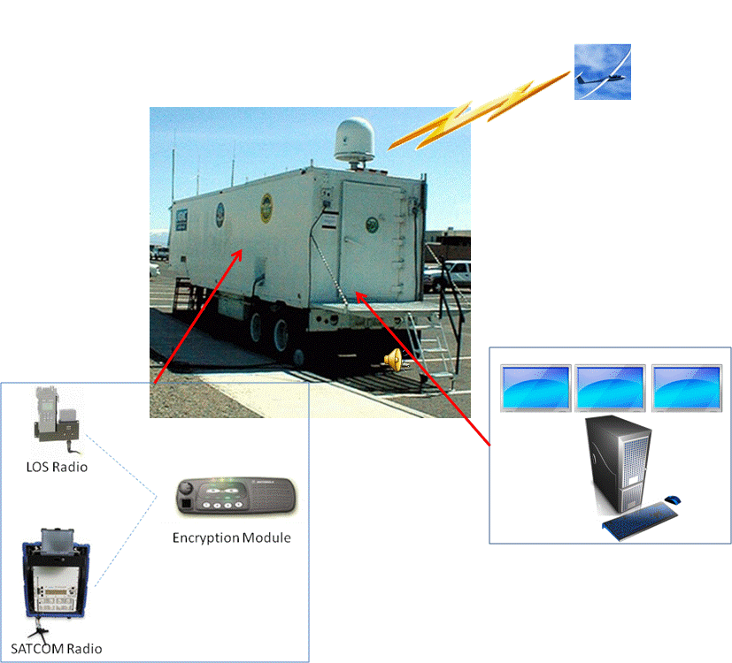
Figure 15: Integrated UCATS Instantiated Architecture

Conclusions
After the UCATS physical and functional architecture was defined the architecture was mapped to UCATS functions to ensure that the functional architecture met all the UCATS requirements as defined in the SRS. The top level requirements are broken down into mission level and operational requirements. These requirements are the allocated to the top level function of UCATS. This is seen in Figure 16 below.
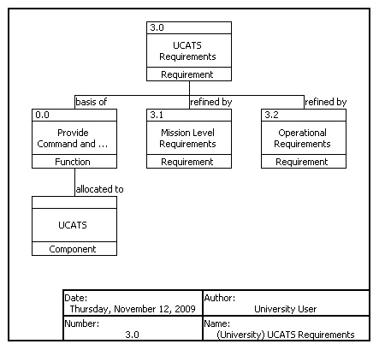
Figure 16: UCATS Top Level Requirements Hierarchy and Functional Mapping

Mission Level Requirements Functional Allocations
The Mission level requirements hierarchy is seen in Figure 17 below. Note, for the Figures below, you must use the zoom functions to clearly view.
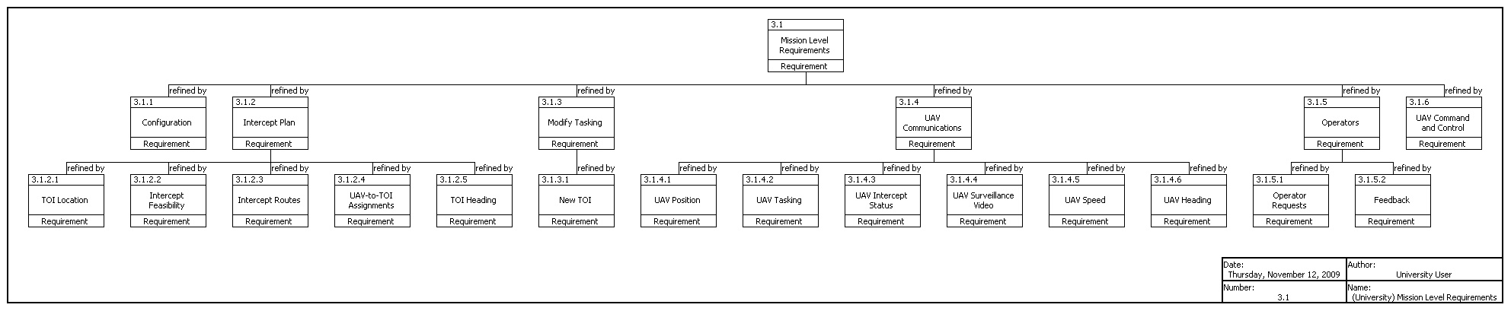
Figure 17: UCATS Mission Level Requirements Hierarchy

The mapping of mission level requirements to UCATS functions is seen in Figure 18 below. Once again to view the figure you must use the zoom function.
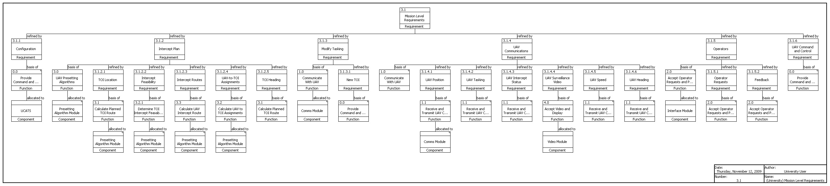
Figure 18: UCATS Mission Level Requirements Hierarchy and Functional Mapping

Operational Requirements Functional Allocations
The operation requirements were also mapped to UCATS functions. The functional mapping is seen in Figure 19 below. Note you must zoom at 500% to view the Figure.

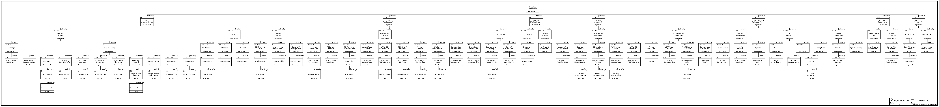
Figure 19: UCATS Operational Requirements Hierarchy and Functional Mapping

APPENDICES

APPENDIX A: Acronyms

UAV Unmanned Aerial Vehicle
UCATS Unmanned Control & Tracking System
TOI Target Of Interest
CSCI Common Software Configuration Item
SW Software
HW Hardware
SLOC Source Lines of Code

APPENDIX B: Functional Architecture AoA

